CHAPTER 14



359

IMPLEMENTING CRM

|  |
| --- |
| CHAPTER OBJECTIVES  By the end of this chapter you will be aware of:   * Five major phases in a CRM implementation. * A number of tools and processes that can be applied in each phase of a CRM implementation. * The importance of project management and change management throughout the implementation process. |

INTRODUCTION

A focus on benefits and the appropriate organization structure with which to deliver them are necessary but not sufficient for CRM success. Also required is an effective project/ programme management plan for CRM implementation. In our experience, marketers are not often skilled programme managers; marketing expertise is based upon customer and competitor insight, co-creating innovative offers with partners and customers and com­municating effectively with customers, not on managing organizational change. Change management is a very complex phenomenon that requires specialist expertise. It is not possible to cover this topic fully in one chapter; here, we highlight some aspects you will wish to consider when ready to implement CRM, so that you might seek out appropriate resources and advice to help you succeed.

We also note CRM professionals often distinguish between projects and programmes, with the latter being larger scale, more systemic changes. Given that readers of this book may be working across programmes and projects of varying complexity and change, we use the terms interchangeably.

In this chapter, we will look at the five major phases of a CRM implementation, and the processes and tools that can be used within those phases to ensure that CRM projects deliver what is expected of them.1 Depending on the scope of the project some of these phases, processes and tools may not be required. The key phases are shown in Figure 14.1.

REALIZING THE BENEFITS OF CRM

Figure 14.1 The five-step implementation process

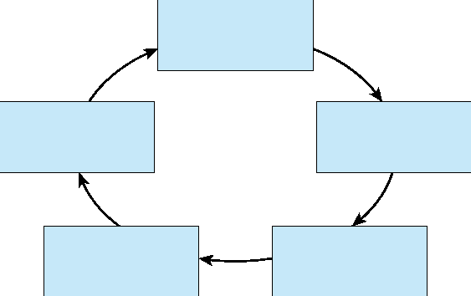

5. Performance evaluation

4. Project  
implementation

1. Develop CRM strategy

3. Needs  
specification and  
partner selection

2. Build  
CRM project  
foundations

1 Develop the CRM strategy

* situation analysis
* commence CRM education
* develop the CRM vision
* set priorities
* establish goals and objectives
* identify contingencies, resources and people changes
* agree the business case with the Board.

2 Build CRM project foundations

* establish governance structures
* identify change management needs
* identify project or programme management needs
* identify critical success factors
* develop risk management plan.



3

* process engineering
* data review and gap analysis



* write request for proposals (RFP)
* call for proposals



* assessment and partner selection. 4 Project implementation



* identify technology customization needs
* prototype design, test, modify and roll out.

|  |  |
| --- | --- |
| 360 |  |

**IMPLEMENTING CRM**

5 Performance evaluation



361

* project outcomes
* business outcomes.

PHASE 1: DEVELOP THE CRM STRATEGY

CRM strategy can be defined as follows:

CRM strategy is a high level plan of action that aligns people, processes and technology to achieve customer-related goals.

Situation analysis

Typically, a CRM programme starts in response to changes in the organization's customer strategy. It helps to have an organizing framework to guide your analysis. The comprehensive models of CRM that are described in Chapter 1 might be helpful. Another useful framework is the Customer Strategy Cube. This is a three-dimensional analysis of your company's served market segments, market offerings and channels (routes-to-market). The situation analysis answers the questions, 'Where are we now?' and 'Why are we where we are?' in terms of the three dimensions of the cube.

Figure 14.2 illustrates the customer strategy cube of a company that sells four different offerings to five different market segments through three different channels. Each block in this cube - there are 60 (5 4 3) of them - might be a potential business unit that would be subject to a situation analysis. In fact, most businesses do not operate in all potential blocks of their customer strategy cube. They operate selectively. For example, AMP sells financial

Customers or segments

1 2 3 4 5



Channels

A 04

03

Offers

02

01

B

C

Figure 14.2 Customer strategy cube

REALIZING THE BENEFITS OF CRM

products through a network of independent and tied financial planners. They do not sell direct-to-consumer. Not all offerings are sold to all market segments through all channels. The situation analysis examines the three dimensions of the customer strategy cube independently and jointly. Questions such as the following are asked:

* Customers or segments: Which segments do we target? Which segments do we serve? What are our customer-related marketing and sales objectives? How much do we sell

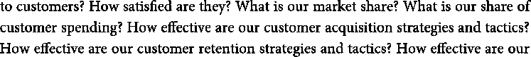

customer development (cross-sell and up-sell) strategies and tactics? What are the customer touchpoints? What do our customers think about their experience of doing business with us? Which customer management processes have most impact on our costs or customer experience? Which technologies do we use to support our marketing, selling and service functions, and how well do they operate?

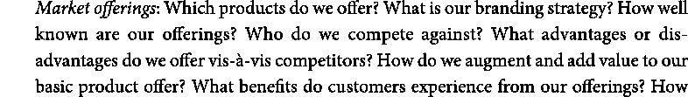

•

do our prices compare with competitors? What are our margins?

* Channels: Which channels do we use to distribute to our customers - direct and



have? Which channels are becoming more/less important? Where do our competitors distribute? What do channel partners think of their experience of doing business with us? What margins do channel members earn? Which channel management processes have most impact on our costs or channel member experience? How are our channels integrated to provide a seamless customer experience?

The goal of this audit is to get a clear insight into the strengths and weaknesses of the company's current customer strategy before creating a CRM vision. Data can be collected from executives, managers, customer-contact people, channel partners and, most importantly, customers. Business plans can be studied. One of the outcomes might be a customer interaction map, as in Figure 14.3, that identifies all customer touchpoints and the processes that are performed at those touchpoints. Normally, the interactions that have important impact on customer experience or your own costs become primary candidates for re-engineering and automation. The audit will serve as the start point for thinking about what you want to achieve from a CRM implementation.

Commence CRM education

CRM, as you have read in Chapter 1, is a term that means different things to different people. It is important that all stakeholders have a clear understanding of what CRM denotes. Your IT people might think that it is a technology project, marketers may think it is campaign management and salespeople may think it is a customer contact database. Sales management

|  |  |
| --- | --- |
| 362 |  |

IMPLEMENTING CRM



363

Figure 14.3 Customer interaction map

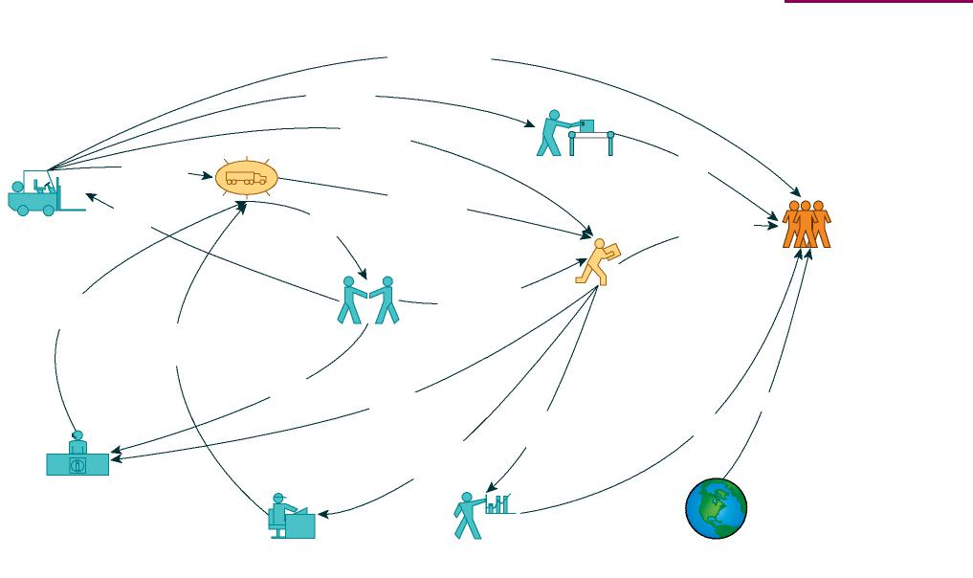

Withdrawal Data

Sales Call, Promotion

Replacement Product

Delivery

Direct Outlet

Wholesaler

Delivery, Invoice

Warehouse

Ullage

Delivery, Invoice

Price List

Price List,  
Delivery,  
Invoice

Retailer

Purchase

Purchase

Consumer

Rebate Payment

Account Manager

Information

Order

Order

Remittance Claim

Direct Mail

Advertising

Sales Support, Customer Service

Accounting AP, AR

Marketing

Websites

may think of CRM as enabling management of the sales pipeline, whilst service management may see CRM principally as a means of reducing cost. This is not problematic if the organization's CRM vision (see next section) is merely a collection of independent point solutions; however, if the firm is giving CRM more strategic consideration, the implications across the organization need to be understood by everyone and agreed.

Develop the CRM vision

Your CRM vision is a high-level statement of how CRM will change the way the business relates to its customers. The vision addresses the need for change and articulates a destination. Examples of CRM visions are:

* We will work with our members in a trust-based relationship to represent their interests, and to satisfy their needs for high value, security and peace of mind in motoring, travel and home.2
* We will build and maintain long-term relationships with valuable customers by creating personalized experiences across all touchpoints and by anticipating customer needs and
* To be able to see all information in one place.3



The CRM vision gives shape and direction to CRM strategy. The CRM vision might be senior management's perspective based on what they learned from the education process, or it could

REALIZING THE BENEFITS OF CRM

be the product of a wider visioning process that engages more members of the company, and perhaps even customers and partners. The vision will eventually guide the development of measurable CRM outcomes.



Set priorities

CRM projects vary in their scope, and can touch on one or more customer-facing parts of your business - sales, marketing and service. Clear priorities for action, normally focused on cost reduction or enhanced customer experience, might fall out of the situation analysis, but more time and debate is often necessary. Priority might be given to projects that produce quick wins or are low cost. Longer-term priorities might prove more difficult to implement. For example, you may want to prioritize a new segment of customers based on their potential profitability. An impediment to that outcome would be your company's inability to trace costs of selling, marketing and service to customers. You may therefore need to prioritize the implementation of an activity-based costing system before performing the new segmentation.

Establish benefits expected - the goals and objectives

Goals and objectives emerge from the visioning and prioritizing processes. Although the terms 'goals' and 'objectives' tend to be used synonymously, we use the 'goal' to refer to a qualitative outcome and 'objective' to refer to a measurable outcome. For example, a CRM goal might be to acquire new customers. A related CRM objective would be to generate 200 additional qualified leads by Q4 of the next financial year.

As shown in Table 14.1, CRM goals generally cluster around three broad themes: enhancing customer satisfaction or loyalty, growing revenues or reducing costs. CRM strategies often pursue several goals simultaneously, for example increasing customer retention and reducing customer service costs.

Table 14.1 Strategic goals for CRM

Increase customer satisfaction Increase sales revenues Reduce cost of sales

Increase customer retention Enhance cross-sell and up-sell Reduce customer service costs

opportunities

Increase customer loyalty Increase customer profitability Reduce marketing costs

Increase partner loyalty Acquire new customers Increase margins

Increase marketing campaign response

Improve lead numbers and quality

|  |  |
| --- | --- |
| 364 |  |

IMPLEMENTING CRM

Identify contingencies, resources and people changes





365

The next step is to build a Benefits Dependency Network (BDN) around the goals. The BDN concept was explained in Chapter 13. The process of thinking about the business changes required in order to achieve the CRM goals is hugely important and ensures that the organization is aware of the scope of change required. Too often, CRM is seen as a marketing (or worse, an IT) project and a 'let them get on with it' attitude prevails. As the programme unfolds, customer managers will start demanding resources and changes to business processes. It is much better to have these matters aired and agreed before spending large amounts on CRM, only to find out that the organization is unable, or unwilling, to develop the complementary capabilities and resources needed to make CRM work.

This step will also ensure that you identify the people, process, organization changes and technology requirements for the goals and objectives to be achieved. You will return to these matters repeatedly as the project unfolds, but at this stage you need a general idea of the changes that are necessary, so that you can begin to identify costs, investments and timescales that form part of the business plan.

Agree the business case with the Board

Whilst we discussed the business case in Chapter 13, it is worth reprising it here. The business case is built around the costs and benefits (identifiable and latent) of CRM and answers the question: 'Why should we invest in this CRM project?'

The business case looks at both costs and revenues. CRM implementations can generate additional revenues in a number of ways. We break these out into benefits that are more likely to be immediately achievable and those that are latent; that is, they become apparent after the organization has developed complementary CRM assets and capabilities.

The costs of a CRM project extend well beyond the costs of CRM software. Additional costs might be incurred from systems integration, infrastructure costs, new desktop, laptop or handheld devices, software configuration, data modelling, beta-testing, helpdesk support,

Table 14.2 Immediate and latent benefits from CRM

* More sales leads • Unspecified new products and services  
  arising from enhanced insight
* More revenues from cross-selling and • Stronger customer partnerships  
  up-selling
* Better margins (yield management) Increased customer satisfaction delivering  
  higher loyalty, willingness to pay and reduced costs-to-serve
* Lower cost-of-sales • Realignment of assets to meet customer  
  needs better
* Increased retention and recommendation
* Lower cost of customer acquisition

REALIZING THE BENEFITS OF CRM

change management, project management, process re-engineering, software upgrades, training and consultancy services, let alone the opportunity costs of diverting your own staff members from their routine work. For a simple CRM project IT costs may represent one-quarter of total project costs; for a complex project IT costs may be as low as one-tenth of total project costs.

Some business cases are able to ignore technology costs. Many companies using enterprise software are already paying for CRM modules in their inclusive licence fees. A licensed SAP-user, for example, might be using enterprise software for back-office functions only. However, the licence fee permits the company to use the enterprise suite's CRM modules. No additional licence costs are incurred. Other companies that elect to deploy CRM through the SaaS approach, rather than installing software on their own hardware, treat CRM software as an operating expense. They simply treat software costs, based on a per-user monthly fee, as an operational expense that can be allocated to marketing, sales or service budgets.

Many of these costs and benefits are measurable, but there are also likely to be some important latent or strategic benefits that are much harder to value, for example development of a customer-centric way of doing business, better customer experience, improved responsiveness to changes in the market or competitive environments, more information sharing between business silos, more harmonious relationships with customers and the development of an information-based competitive advantage.

PHASE 2: BUILD CRM PROJECT FOUNDATIONS

Having created the CRM strategy, BDN and business case the next phase involves building the foundations for the CRM implementation.

Establish governance structures

CRM projects are designed and implemented by people. Governance structures (see Figure 14.4) need to be put in place to ensure that project roles and responsibilities are properly defined and allocated.

The Programme Director (PD) plays an important role in this structure. Ultimately, the PD has responsibility for ensuring that the project deliverables are achieved, and that project costs are controlled. The PD in larger projects is a full-time appointment. The PD has a boundary-spanning role - one foot is in the CRM Steering Committee, the other is in the Programme Team. Another key member of the Steering Committee is the executive sponsor. This is typically a Board-level senior executive who commits real time to the project and ensures that resources are made available. The Steering Committee makes policy decisions about the CRM implementation - for example, which technology to buy, which consultants to hire - and ensures that the implementation stays on track and within budget. Other senior executives may sit on the Steering Committee to ensure that the project remains business-focused and does not slide into being an IT-dominated project. The Programme Team is composed of representatives from the major stakeholders. They have the responsibility for implementing the project successfully. The stakeholder representatives may have their own advisory groups that ensure that stakeholder needs and concerns are known and brought to

|  |  |
| --- | --- |
| 366 |  |

IMPLEMENTING CRM



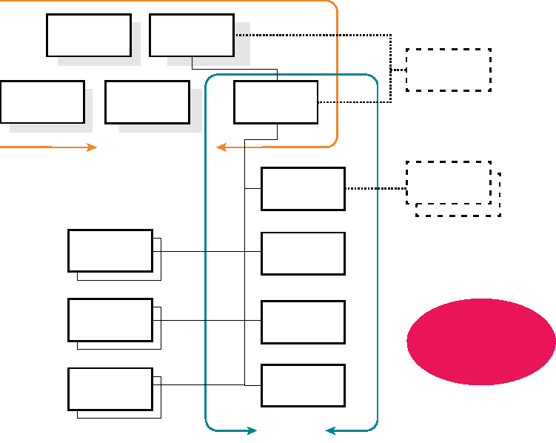

Sales  
Executive

CEO

Key Users

Key Users

Key Users

Steering Committee

Marketing Executive

Executive Sponsor

Programme Director

Programme Team

Sales Lead

Marketing Lead

Support Lead

IS Lead

Systems  
Implementer

CRM  
Consultant

External Resources

Customer Advocate

Figure 14.4 Governance structure4



outcomes.



367

the Programme Team. CRM implementations can impose considerable demands on a company's own internal IT resources which might be called on to perform several project-related roles. The lead developer role ensures that the CRM software is customized to meet the needs of users. The database developer role ensures that customer-related data held in disparate databases are made available to end-users in the form required for operational and analytical CRM applications. The front-end developer role ensures that the user interface is easy to understand and use.

It is not uncommon for CRM projects to import resources and talents to help deliver the project. This governance structure shows a CRM consultant working with the Steering Committee. It is unlikely that an in-house Steering Committee has sufficient experience of CRM project implementations. An experienced consultant can help the Steering Committee overcome problems as the project progresses. A systems implementer is also shown in this governance structure as an important external resource. For an installed CRM system, vendors generally supply technical help to ensure that the system is properly implemented. The implementer has a boundary-spanning role, being an employee of the vendor but working on site as the client's advocate.

A systems integrator may also be needed to align disparate systems into a coherent whole to support the project objectives. Systems integration can be defined as follows:

Systems integration is the practice of aligning and combining system components

REALIZING THE BENEFITS OF CRM

Very often, desired CRM outcomes are impeded by the poor interoperability of IT systems. For example, the IT system that supports Web operations may be incompatible with the IT system that supports the call centre. The result is that there may be two different databases containing important customer-related information. A systems integrator might be needed to programme the interface that links the two systems.

Finally, the governance chart shows that the voice-of-the-customer has to be heard in the project team. Customers of companies that implement CRM are important stakeholders, because their experience of doing business will change. Some CRM projects fail to deliver optimal outcomes because the project team fails to ask, 'What would the customer think?'

Identify change management needs

Even small CRM projects can prove challenging in terms of change management. A sales force automation project might involve centralizing data that are presently kept on individual reps' laptops, and making that information available to all in the team. Reps will have to learn to share. In a distributed sales force, these reps may have not even met each other. If they have to change their selling methodology, record keeping and reporting habits as well, there just might be some worry, if not outright resistance.

According to consultants Booz Allen & Hamilton, 'Leadership teams that fail to plan for the human side of change often find themselves wondering why their best-laid plans go awry.'5 They describe change both in terms of top-down leadership and bottom-up buy-in, as does John Kotter whose eight-step approach to managing change is widely cited and deployed.6 The eight steps are as follows:

1 Create a sense of urgency so that people begin to feel 'we must do something'.



described above).

3 Get the vision right, and build supporting strategies.

4 Communicate for buy-in.

5 Empower action by removing organizational barriers to change.



7 Don't let up, but keep driving change and promoting the vision.

8 Make change stick by reshaping organizational culture.

Kotter emphasizes that successful change management programmes adopt a see-feel-change approach. To bring about change it is necessary not only to get people to see the need for change, but also to feel so emotionally engaged that they want to change. He stresses the importance of emotional engagement with the programme's vision and strategies.

Organizational culture

The concept and composition of organizational culture is hotly contested. Organizational culture is a well-researched and complex phenomenon, and it is not possible to do it full justice in a section of a chapter in a book on CRM. However, with CRM project failure rates

|  |  |
| --- | --- |
| 368 |  |

IMPLEMENTING CRM

reported at high levels,' CRM leaders must be sensitive to the 'culture' in which they wish to implement CRM. We outline some aspects that we believe are important for project managers to understand.

In everyday language, organizational culture is what is being described when someone answers the question 'What is it like working here?' More formally, organizational culture can be defined as

A pattern of shared values and beliefs that help individuals understand organizational functioning and thus provide them with the norms for behavior in the organization.8

Essentially, organizational culture comprises widely shared and strongly held values. These values are reflected in patterns of individual and interpersonal behaviour, including the behaviour of the business leaders, and expressed in the norms, symbols, rituals and formal systems of the organization.

A number of studies indicate that organizational culture affects business performance.9 Recent research has also shown that organizational culture is a predictor of CRM success.10 Adhocracy, one of four organizational cultures identified in the Competing Values model (Figure 14.5), shows the strongest association with CRM success. Adhocracies are highly flexible, entrepreneurial, externally oriented organizations. Their core values are creativity and risk-taking.

Cameron and Quinn have developed a process for companies wishing to change their culture as indicated by the Competing Values model.11 They suggest that cultural change may involve adjustment to the organization's structure, symbols, systems, staff, strategy, style of leaders and skills of managers, but emphasize that individual behavioural change is the key to culture change.

Flexibility and Discretion

Internal Focus and

Integration

External Focus and

Differentiation

|  |  |
| --- | --- |
| Clan | Adhocracy |
| Hierarchy | Market |

Stability and Control



369

Figure 14.5 The Competing Values model of organizational culture12

REALIZING THE BENEFITS OF CRM

Buy-in

As noted by John Kotter, buy-in operates at an emotional or intellectual (rational) level. Intellectual buy-in is where people know what has to be changed and understand the justification for the change. New technologies are adopted more quickly when users believe that the system will be easy to use. Emotional buy-in is where there is genuine heartfelt enthusiasm, even excitement, about the change. The matrix in Figure 14.6 shows the possibility of four employee segments, reflecting the presence or absence of emotional and rational buy-in. Champions are emotionally and rationally committed. Weak links are neither emotionally nor rationally committed. Bystanders understand the changes being introduced, but feel no emotional buy-in to the change. Loose cannons are fired up with enthusiasm but really do not understand what they have to do to contribute to the change. All these segments will be found in major change projects such as a CRM implementation.

The CRM project's vision and goals need to be accepted by each of these groups in different ways. The Programme Team's challenges are to encourage bystanders to become passionate about the project's goals, and to educate loose cannons on the reasoning behind CRM. Weak links can be truly problematic if they are in customer-facing roles or impact on customer experience. It has been said that it takes many years to win a customer's confidence and trust, but only one incident to break it. If efforts to win them over fail, weak links may need to be reassigned to jobs where there is no customer impact.

Identify project or programme management needs

CRM implementations can place considerable demands on project management skills and CRM project leaders need to understand their organization's capacity to manage complex change projects successfully.

The CRM project plan spells out the steps that will get you from where you are now (customer strategy situation analysis) to where you want to be (CRM vision, benefits, goals and objectives), on time and within budget. The CRM programme director generally performs the project management role, but sometimes it is outsourced to a consultant. A project plan

|  |  |
| --- | --- |
| Bystanders | Champions |
| Weak links | Loose cannons |

Yes

Intellectual buy-in

No

No Yes

Emotional buy-in

Figure 14.6 The buy-in matrix

|  |  |
| --- | --- |
| 370 |  |

IMPLEMENTING CRM

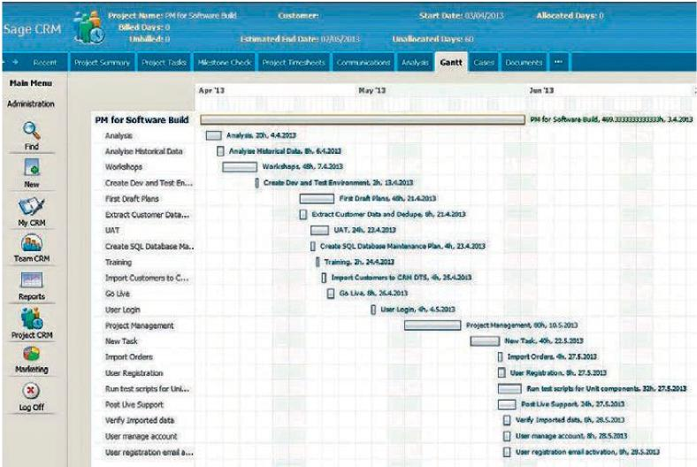

Figure 14.7 CRM project Gantt chart13



371

sets out the tasks to be performed, the order in which they are to be performed, the time each will take, the resources required to perform the tasks (including people and money) and the deliverables from each task. Tools such as Gantt charts, Critical Path Analysis (CPA), Programme Evaluation and Review Technique (PERT) or network diagrams are useful tools for project managers. Some tasks will be performed in parallel, some in sequence. As the project rolls forward there will be periodic 'milestone' reviews to ensure that it is on time and on budget. A CRM project that has the goal of improving the productivity of marketing campaigns might be made up of a number of tasks or mini-projects, each with its own deliverable and time-line, including the following: market segmentation project, database development project, creation of a new campaign management process, management reports project, technology search and selection project, and a user training project.

Identify critical success factors

Critical success factors (CSFs) are the 'must haves' that underpin project success. Critical success factors can be defined as follows:



CRM consultants and vendors offer a range of opinions on CSFs, mentioning the following: a clear customer strategy that defines your company's offers, markets and channels; an organizational culture that promotes coordination and information-sharing across business units; an agreed definition of what counts as CRM success; executive sponsorship of the CRM programme's objectives; availability and use of pertinent, accurate, timely and usable

REALIZING THE BENEFITS OF CRM

customer-related information; a clear focus on people and process issues, not only tech­nology; starting small with quick wins that are then promoted within the company as success stories; focus on automating processes that have major implications for costs or customer experience; and engagement of all stakeholders, including end-users and customers, in programme planning and roll-out.

There have been very few independent studies of CRM CSFs. Da Silva and Rahimi1ì conducted a single CRM case-study test of three CSF models that had originally been developed in the context of Enterprise Resource Planning (ERP) implementations. They found that CRM CSFs could be categorized as strategic and tactical. Strategic CSFs are encountered at the beginning of the project, while tactical CSFs become important later. Strategic CSFs include a clear CRM philosophy (we prefer the term 'vision% top management commitment and project management expertise. Tactical CSFs include troubleshooting skills, good communications and software configuration.

Croteau and Li conducted an empirical assessment of CRM CSFs in 57 large Canadian organizations.15 Focusing only on the technology element - therefore ignoring people and process issues - they conclude that the CSF most strongly associated with CRM success is an accurate and well-developed knowledge management system. This has to be supported by a suitable IT infrastructure which can capture, manage and deliver real-time customer, product and service information in order to improve customer response and decision making at all customer touchpoints. They also found that another important CSF is top management support.

Luis Mendoza and his colleagues conducted a qualitative study of CSFs that involved a panel of eight expert judges identifying 13 CSFs and 55 associated metrics covering people,

Table 14.3 Critical success factors for successful CRM strategies



|  |  |  |  |  |
| --- | --- | --- | --- | --- |
| 1 | Senior management commitment | X |  |  |
| 2 | Creation of a multidisciplinary team | X | X |  |
| 3 | Objectives definition | X |  |  |
| 4 | Interdepartmental integration | X | X |  |
| 5 | Communication of the CRM strategy to staff | X | X |  |
| 6 | Staff commitment | X |  |  |
| 7 | Customer information management |  |  | X |
| 8 | Customer service |  | X | X |
| 9 | Sales automation |  | X | X |
| 10 | Marketing automation |  | X | X |
| 11 | Support for operational management | X | X | X |
| 12 | Customer contact management | X |  | X |
| 13 | Information systems integration |  |  | X |

: More important CSFs are bold typeface.



|  |  |
| --- | --- |
| 372 |  |

IMPLEMENTING CRM

process and technology aspects of CRM strategy.16 The CSFs and their alignment with people, process and technology appear in Table 14.3, the most important being highlighted in bold.



373

Develop risk management plan

Research suggests that a large number of CRM projects, perhaps as many as half or even two-thirds, fail.17 Of course, there can be many potential causes of failure, ranging from outrageously ambitious objectives, through inadequate project management to resistance of end-users to the adoption of new technologies. At this step of the CRM implementation process, you will be trying to identify the major risks to achieving the desired outcomes. Once identified, you can begin to put risk-mitigation strategies and contingency plans in place. As you would expect, some risks reflect an absence of the CSFs identified above. Gartner Inc. names a number of common causes of CRM failure: management that has little customer understanding or involvement; rewards and incentives that are tied to old, non-customer objectives; organizational culture that is not customer-focused; limited or no input from customers; thinking that technology is the solution; lack of specifically designed, mutually reinforcing processes; poor-quality customer data; little coordination between departmental initiatives and projects; creation of the CRM team happens last, and the team is composed of IT people, but lacks business staff; no measures or monitoring of benefits, and lack of testing.18

Risk-mitigation strategies are your responses to these risks. Let's take the risk of management having little or no customer understanding. How might you respond to this? There are a number of things you could do - management could work in the front-line serving customers (executives at McDonald's do this), listen in to call centre interactions for at least one hour a week, or mystery shop your own and competitor organizations.

PHASE 3: NEEDS SPECIFICATION AND PARTNER SELECTION

Having built the CRM project foundations, the next phase involves specifying needs and selecting suitable partners.

Process engineering

The first task of phase 3 is to identify business processes that need attention - making them more effective or efficient, or flagging them as candidates for automation. Business processes can be defined as follows:

A business process is a set of activities performed by people and/or technology



and end point.

Put more simply, business processes are how activities are performed by the company. Processes can be classified in several ways: vertical and horizontal; front office and back office; primary and secondary.

REALIZING THE BENEFITS OF CRM

* Vertical processes are those that are located entirely within a business function. For example, the customer acquisition process might reside totally within the marketing department. Horizontal processes are cross-functional. New product development





development groups.

I

complaints-handling process is an example. (or back-stage) processes are

invisible to customers, for example the procurement process. Many processes straddle



A distinction is also made between primary and secondary processes. Primary processes have major cost implications for companies or, given their impact on customer experience, major revenue implications. The logistics process in courier organizations - from picking up a package through moving the package to delivering the package - constitutes about 90 per cent of the cost base of the business, and is therefore a primary process. Customers may have a different perspective on what is important. They typically do not care about back-office processes. They care about the processes they touch. In the insurance industry these are the claims process, the policy renewal process and the new policy purchase process. In the courier business they are the pick up, delivery and tracking processes.

Secondary processes have minor implications for costs or revenues, or little impact on customer experience.

Strategic CRM aims to build an organization that is designed to create and deliver customer value and experience consistently better than competitors to targeted customers. Designing processes that create value for customers is clearly vital to this outcome. 3M's customer promise is 'Practical and ingenious solutions that help customers succeed'. It does this in part through new product development processes that are designed to identify good ideas and bring them to the market quickly.19 For 3M, the innovation process is a primary process that enables the company to differentiate itself from competitors.

Operational CRM involves the automation of the company's selling, marketing and service processes and generally requires the support of analytical CRM. Figure 14.8 shows the campaign management process for a particular customer offer made by First Direct, a UK-based online and telephone bank. It shows that the propensity of a customer to open a high interest savings account is determined by a scoring process that considers both demographic and transactional data. The propensity modelling process is an illustration of analytical CRM. If a target score is reached an offer is made either by the customer service agent during the phone call or at a later time by email. This automation of the selling process is an example of operational CRM.

Flowcharting, which is also known as blueprinting and process mapping, is a tool that can be used to make processes visible. The flowchart sets out the steps involved in performing the process. It may also identify the people (or roles) that contribute to the process, and the standards by which the process is measured, such as time, accuracy or cost. Processes always have customers, who may be either internal or external to a company. Customers receive process outputs. Workflow functionality is embedded into many CRM applications and is

|  |  |
| --- | --- |
| íéì |  |

IMPLEMENTING CRM

Customer  
phones in

Check scores





Open account  
on phone

42

Check account  
balance

(numbers are days)



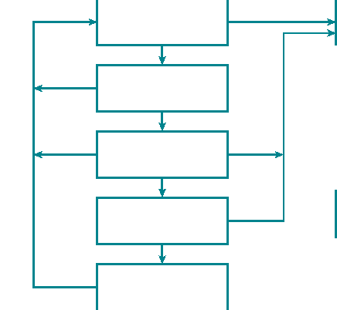

No interest

Outbound phone follow-up

Send application form

Offer product to high scores

Mail follow-up

Do nothing

2

7

7

Buy product

Figure 14.8 Campaign management process for high interest saving account Evaluating processes2°



375

Table14.4



Best practice The process is substantially defect-free and contributes to CRM

(superiority) performance. Process is superior to comparable competitors' and other

benchmarks

Parity A good process which largely contributes to CRM performance

Stability An average process which meets expectations with no major problems

but which presents opportunities for improvement

Recoverability The process has identified weaknesses which are being addressed

Criticality An ineffective and/or inefficient process in need of immediate remedial

attention

used for process mapping. Flowcharts can be used to identify fail points where a process frequently breaks down, redundancies and duplications. They can also be used for induction and training of new people, and for illustrating internal customer-supplier relationships.

Processes can be rated according to the degree to which they can be improved. It has been suggested, for example, that processes be rated according to the criteria in Table 14.4.

Data review and gap analysis

Having identified processes for attention, the next step is to review the data requirements for the CRM implementation, and to identify shortfalls.

Strategic CRM uses customer-related data to identify which customers to target for acquisition, retention and development, and what to offer them. Operational CRM uses

REALIZING THE BENEFITS OF CRM

customer-related data in the everyday running of the business, for example in handling billing queries in the contact centre, or mounting campaigns in the marketing department. Analytical CRM uses customer-related data to answer questions such as: 'Who are our most profitable customers?' and 'Which customers are most likely to churn?' The fundamental issue companies have to ask is: What customer-related data do we need to achieve the CRM programme's goals and objectives?

Members of the Programme Team should be well placed to answer the question 'What information is needed?' For example, the Programme Team's marketing lead would be expected to appreciate the information needs of marketers running event-based campaigns. Typically, these marketers want to know response rates to previous mailings broken down by customer group, the content of those offers, sales achieved by these mailings and the number of items returned unopened. They would also want to know the names and addresses of selected targets, their preferred method of communication (Mail? Email? Phone?), their preferred form of salutation (First name? Mr? Ms?) and what offers have been successful in the past.

At this stage of planning the CRM project, you are identifying the data that are needed for the defined CRM purposes, and creating an inventory of data that are currently available. The gap between what are available and what are needed may be quite significant. A useful distinction can be made between 'need-to-know' and 'like-to-know'; that is, between information needed for CRM purposes, and information that might be useful at some future point. Given the costs of developing and maintaining customer-related databases, companies need to be rigorous in screening data requirements. Another data review issue is the quality of the available data. It is one thing to have available data; it is another for that data to be of good quality. In general, higher quality data are required for operational CRM applications than for analytical CRM. Operational CRM systems interact with customers. If a customer service agent calls a customer with a gender-specific offer only to find that the expected Mr turns out to be a Ms the offer is almost bound to fail. On the other hand if there are gender errors in the customer record it makes little difference to the prediction of churn.

Initial technology needs specification and research alternative solutions

Earlier in this implementation process, you began to consider technology requirements. Now you can return to this question with a clearer focus on the process and data issues. There are a huge number of software applications that fall under the heading of CRM, many of which we discuss in Chapters 8-12. You now need to decide what applications will deliver your CRM vision and meet the business case requirements. You can learn about these applications by visiting vendor websites, joining online communities, such as [www.customerthink.com](http://www.customerthink.com), or attending physical or virtual (online) exhibitions.

The 'real options' approach to CRM investment that we discussed in Chapter 13 has implications for the decision to build, buy or rent the CRM applications that you choose. Your options are to build your CRM applications from scratch, to buy an on-premise site licence or pay a monthly per-user charge for an on-demand solution. If you opt to build from scratch you may find that some open-source modules provide much or all of what you need.

|  |  |
| --- | --- |
| 376 |  |

IMPLEMENTING CRM

Open-source software is peer-reviewed software that gives CRM application developers the opportunity to view and evaluate source code. Open source advocates suggest that being able to modify source code leads to improved software with fewer bugs, and that free distribution leads to more developers working to improve the software. The second alternative is to license CRM applications. The final alternative is to pay a monthly per-user fee for an on-demand (hosted) solution.



377

Hosted or on-premise CRM

As the market for CRM software matures, companies have a choice of excellent products almost all of which are fit for purpose. An important decision is how to access CRM functionality. CRM software is distributed in two ways. It can be installed on your company's own servers or it can be accessed on another party's servers via the Internet. The former is known as on-premise, offline or installed CRM, an option that has been the preferred mode for many large-scale enterprises and early adopters of CRM. The alternative is known as hosted or online CRM, Web-service, the ASP (Application Service Provider) model, or the Software as a Service (SaaS) model.

The hosted option is becoming more popular as CRM solutions are adopted by mid-market and smaller enterprises. Some larger organizations are also opting for online CRM solutions, and many enterprises are using a hybrid mix of hosted and on-premise solutions, which is feasible when the underlying data model is the same.21 Hosted CRM applications deliver very much the same functionality as their on-premise competitors, including advanced functionality for competitive intelligence, social media integration, pricing, content management, data warehousing, marketing analytics and workflow design.22

The choice of delivery model is often determined by consideration of total cost of ownership (TCO). TCO can be computed over different time periods, say one, three and five years. TCO may indicate that hosted is a better solution than on-premise for a small business's sales force automation project for ten sales reps. However, for a large-scale business transformation project with significant changes to business processes in sales, marketing and customer service, on-premise solutions may offer a better TCO. TCO of hosted solutions is largely a matter of the total number of seats (CRM users) using the CRM solution. Hosted solutions offer easy and immediate scalability, substitution of fixed cost with variable cost (lower risk), regular updates to the software's functionality freely provided by the cloud-based supplier, maintenance, user training and online support and, of course, virtually no support costs. TCO for on-premise solutions needs to consider additional costs such as systems integration (integrating the CRM technology with the business's back-office processes, for example), customization, user training, additional IT staff members, additional hardware (such as Web servers), support and periodic application upgrades.

There have been a number of published comparisons of the TCO of hosted versus installed,23 and they vary in their conclusions. Some suggest the TCO of hosted CRM is superior; others say the TCO of installed CRM is superior, particularly over the longer term. The TCO of hosted versus installed clearly depends on the scope of the CRM project (ten users versus 500 users; point CRM solution versus enterprise-wide CRM deployment) and the timescale over which TCO is computed. Readers are therefore advised to consider their particular circumstances in computing TCO.

REALIZING THE BENEFITS OF CRM

The decision to opt for hosted over on-premise, or vice versa, may be significantly dependent on answers to the following questions:

1 Are you willing to commit? Investing big money in a CRM programme and the necessary



business is unsure what it wants, or simply wants to learn from trial-and-error or experience, hosted solutions may be a better option.

2 Does your company have the in-house IT skill set to install, maintain and support an

likely it will need to integrate with other business technologies. For example, you might

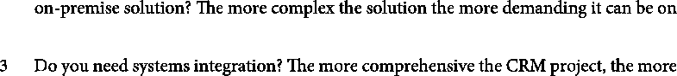

IT resources.



best prospect of successful systems integration. Hosted CRM systems are not integrated with other user company technologies. However, hosted CRM providers are striving to



integrated functionality such as mapping systems (used by marketers) and global positioning systems (used by sales reps).

4 Is your business stable, growing or contracting? Some installed applications can be



cycles change. Hosted solutions do not present that problem.

5 What do you know about the technology partner? Big names like SAP, SAS, IBM and



CRM solutions. Other hosted solutions brands such as [salesforce.com](http://salesforce.com) and NetSuite are well established and have good reputations. You may feel you can trust your valuable customer-related data to these names, but not some of the less-established names. When you outsource customer data-storage to a hosted solutions provider, you are also outsourcing data security. You need to consider whether their security standards compare favourably to your own in-house data security.

In addition to the costs of CRM applications, businesses also need to consider hardware issues. What sort of device is best suited to sales, service and marketing users? Perhaps salespeople need a tablet or smart phone for easy portability, whereas the contact centre prefers desktops, and marketing people prefer laptop computers. Table 14.5 offers a comparison of tablet and laptop attributes.

Write request for proposals (RFP)

Before calling for proposals you need to write a detailed RFP. This document becomes the standard against which vendors' proposals are evaluated. It summarizes your thinking about the CRM programme and invites interested parties to respond in a structured way. Typical contents of the RFP include:

|  |  |
| --- | --- |
| 378 |  |

IMPLEMENTING CRM



On-screen legibility

379

Table 14.5 Comparing laptops and tablets24



Content Full Narrow

Size XXXX X

Portability Moderate High

Speed of input Fast Slow

XXXX X

Stickiness Moderate High

Walk and use No Yes

Presentations Excellent Poor

Replacement cost High Moderate

Synchronization Good Excellent

1 Instructions to respondents.

2 Company background.



4 Strategic, operational and analytical CRM requirements.

5 Process issues:

a customer interaction mapping

b process re-engineering.

6 Technology issues:

a delivery model — SaaS, on-premise, blended

b functionality required — sales, marketing and service

c management reports required

d hardware requirements

e architectural issues

f systems integration issues

g customization issues

h upgrades and service requirements

i availability of free-trial periods.

7 People issues:

a project management services

b change management services



8 Costing issues — TCO targets.

9 Implementation issues — pilot, training, support, roll-out, time-line.

10 Contractual issues.

REALIZING THE BENEFITS OF CRM

11 Criteria for assessing proposals.

12 Time-line for responding to proposals.

Call for proposals

The next step is to invite potential partners to respond to the RFP. You will see from the RFP contents that CRM projects sometimes require input from several process, people and technology partners. On the technology side, if your company is already paying for CRM modules as part of its enterprise IT system, you will certainly want to add this technology vendor to the list of those invited to respond. Between three and six potential technology vendors are typically invited.

Revised technology needs identification

Proposals from technology vendors will sometimes identify opportunities for improved CRM performance that you may not have considered. Perhaps there is some functionality or issue that you had not considered. For example, you might not have considered the need to provide implementation support to sales reps in the field. A vendor that indicates that they will be able to help reps learn the new technology in remote locations might be very attractive.

Assessment and partner selection

The next stage is to assess the proposals and select one or more partners. This task is generally performed by the Steering Committee. Assessment is made easier if you have a structured RFP and scoring system. There are two types of scoring system: unweighted and weighted. An unweighted system simply treats each assessment variable as equally important. A weighted system acknowledges that some variables are more important than others. These are accorded more significance in the scoring process. Some criteria, for example the availability of some essential functionality, may be so important that their absence prevents detailed consideration of the rest of the partner's proposal.

PHASE 4: PROJECT IMPLEMENTATION

So far, you have developed the CRM strategy, built the CRM project foundations, specified your needs and selected one or more partners. It is now implementation time!

Refine project plan

The first step of phase 4 requires you to cooperate with your selected partners in refining the project plan. Remember, this was originally defined without consideration of the needs and availability of your partners. You may find that your partner's consultants are already committed to other projects and that you will have to wait. Your partners will be able to help you set new milestones and refine the budget.

|  |  |
| --- | --- |
| 380 |  |

IMPLEMENTING CRM

Identify technology customization needs



381

It is very common that off-the-shelf technology fails to meet all the requirements of users. Some vendors have industry-specific versions of their CRM software. Oracle, for example, offers a range of CRM suites for banking, retail, public sector and other verticals. Even so, some customization is often required. The lead developer, database developer and front-end developer, in partnership with vendors, can perform these roles.

Prototype design, test, modify and roll out

The output of this customization process will be a prototype that can be tested by users on a duplicated set, or a dummy set, of customer-related data. End-user tests will show whether further customization is required. Final adjustments to marketing, selling and service processes are made at this stage, and further training needs are identified and met. After a final review, a roll-out programme is implemented. In most companies this is a phased roll­out. A new contact management system might be rolled out to the key account team before other members of the sales team; a new campaign management module may be trialled on newer brands rather than established brands; a sales force automation system might be rolled out first to the 'champions', those identified earlier as buying in both emotionally and rationally. The idea is to iron out any problems before company-wide adoption.

PHASE 5: PERFORMANCE EVALUATION

The final phase of the CRM project involves an evaluation of its performance. How well has it performed? Two sets of variables can be measured: project outcomes and business outcomes/benefits realized. Project outcomes focus on whether the project has been delivered on time and to budget. Your evaluation of the business outcomes or benefits requires you to return to the project objectives, your definition of CRM success, and the business case and ask whether the desired results have been achieved.

If your single goal was to enhance customer retention rates, with a measurable lift from 70 per cent to 80 per cent, and this is accomplished then your CRM project has been successful. Congratulations! However, most projects have multiple objectives and it is common for some objectives to be achieved and others to be missed. Lead conversion by the sales team might rise, but lead generation by campaign managers might fall short of objective. A critical issue concerns the timing of any business performance evaluation. It can take users several months to become familiar with new processes, and competent in using new technology. Periodic measures of business outcomes can be taken over time, to ensure that the programme outcomes are achieved. Ongoing training, timed to coincide with software upgrades, can enhance business outcomes. In the short term it is generally impossible to assess whether the latent benefits specified in the business case have been achieved.

REALIZING THE BENEFITS OF CRM

|  |
| --- |
| SUMMARY  In this chapter, you have learned about the five major phases of a CRM imple­mentation, and the processes and tools that are used to ensure that CRM projects deliver what is expected of them. The key phases are: (1) Develop the CRM strategy; (2) Build the CRM project foundations; (3) Needs specification and partner selection; (4) Project implementation; and (5) Performance evaluation. CRM projects vary in scope, duration and cost, but it is always important to be clear about what business outcomes are desired, and to measure the performance of the CRM implementation accordingly. |

NOTES AND REFERENCES

(Accessed 26 June 2007).

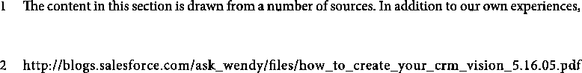

important contributions are made by John Turnbull, Managing Director of Customer Connect ([www.customerconnect.com.au](http://www.customerconnect.com.au)), and Gartner Inc. ([www.gartner.com](http://www.gartner.com)).

3 <https://vwcrmhandbook.pbworks.com/w/page/52098383/Basis%20of%20your%20strategy> (Accessed 23 April 2014).

4 Courtesy of Customer Connect Australia [www.customerconnect.com.au](http://www.customerconnect.com.au) Used with permission.



6 Kotter, J.P. and Cohen, D.S. (2002).

organizations. Boston, MA: Harvard Business School Press.

7 Buttle, F. and Ang, L. (2004). ROI on CRM: a customer journey approach. www.crmsearch.com/ crm-failures.php (Accessed 24 April 2014).



research agenda. Journal of Marketing, 53(January), 3-15.

9 Deshpandé, R., Farley, J.U. and Webster, Jr, F.E. (1993). Corporate culture, customer orientation,

Journal of Marketing, 57(January),



outcomes? Journal of Marketing Management, 29(3/4), 467-93.



23-37.

11 Cameron, K.S. and Quinn, R.E. (1999). Diagnosing and changing organisational culture. Reading, MA: Addison-Wesley.

12 Cameron, K.S., and Quinn, R.E. (1999). Diagnosing and changing organisational culture. Reading, MA: Addison-Wesley.

13 Enbu Consulting: <http://www.enbuconsulting.com/products_projmgr.php?pgurl=projmgr> (Accessed 23 April 2014).

14 Da Silva, R.V. and Rahimi, I.D. (2007). A critical success factor model for CRM implementation. Inernational Journal of Electronic Customer Relationship Management, 1(1), 3-15.

15 Croteau, Anne-Marie and Li, P. (2003). Critical success factors of CRM technological initiatives. Canadian Journal of Administrative Sciences, 20(1), 21-34.

16 Mendoza, L.E., Marius, A., Perez, M. and Griman, A.C. (2007). Critical success factors for a CRM

strategy. , 49, 913-45.



|  |  |
| --- | --- |
| 382 |  |

IMPLEMENTING CRM

17 Buttle, F. and Ang, L. (2004). ROI on CRM: a customer journey approach. <http://www>. [crm2day.com/library/EpFlupuEZVRmkpZCHM.php;](http://crm2day.com/library/EpFlupuEZVRmkpZCHM.php;) Davids, M. (1999). How to avoid the 10 biggest mistakes in CRM. Journal of Business Strategy, November/December, 22-6; <http://www.crmsearch.com/crm-failures.php> (Accessed 24 April 2014).



íèí

18 [www.gartner.com](http://www.gartner.com)

19 Treacy, M. and Wiersema, F. (1995) . London: Harper Collins.



20 Adapted from Jones, P.A. and Williams, T. (1995). Business improvement made simple. Northampton: Aegis Publishing.

21 A data model is an abstract description of how data are organized in an information system or database.

22 For a review of hosted CRM, refer to Buttle, F. (2006). Hosted CRM: literature review and research questions. Macquarie Graduate School of Management, working paper 2006-1.

23 eMarketer (2005). CRM spending and trends. <http://www.emarketer.com/Report.aspx?crm_aug05> (Accessed 21 August 2005); Meta Group (2004). Hosted CRM: the real cost. <http://www.meta>



top 10 myths of hosted CRM. <http://www.aplicor.com/4%20Company/10%20Myths%20of%20> Hosted%20CRM%20Whitepaper.pdf (Accessed 20 October 2005).

24 Courtesy of Customer Connect Australia [www.customerconnect.com.au](http://www.customerconnect.com.au) Used with permission.

This page intentionally left blank